WHOI GO-BGC Navis Floats: Deployment Procedures
Updated April 19, 2023
(D. Nicholson, R. Anderson, S. Traylor)

Contact: Roo Nicholson <dnicholson@whoi.edu> , Aidan Thayer <aidan.thayer@whoi.edu>

Adapted from SOCCOM BGC Floats Deployment manual (S. Riser, R. Rupan, D. Swift, K. Johnson, C. Sakamoto, L. Talley)

General information
The WHOI GO-BGC Floats in use are the Seabird Navis floats.
Do not deploy in water shallower than 2500 m, to avoid grounding. Please deploy floats before you reach the shallows as necessary. Please deploy no closer than 50 km to the existing ice edge, so that at least the first profile, taken within 24 hours, is returned immediately.
Please be careful with the float. Navis floats have been built to be rugged, but also are high performance instruments, so they should be handled carefully. Pay careful attention to not damage the antenna, CTD, and sensors.
Do not connect the float to a computer, the floats are already activated.
Do not swipe the float with a magnet, the float is already activated

Supplies Needed:
- One line that is twice the length of free-board plus 10' to tie off to a cleat.
- The line used needs to be smooth and thin enough to pass through the deployment disk to avoid any snagging on the disk when the line is pulled through.

Deploying Navis floats:

- Steam about 1 km or 1 nm away from CTD station. The CTD profile creates a localized oily patch which we want to avoid. The float can also be deployed 1 km before or after arriving at a CTD profile location.

- Remove the float from the crate. Please be sure to lift from the pressure case. The antenna and CTD are not to be used as handles. The SUNA sensor can be used to lift.

- Move float to deployment area. There are foam supports in the crate. Put the supports on the deck deployment area and lay the float on the supports (tie down if necessary).
  - Depending on the ship, it may be optimal to deploy off the stern or lee-side stern-quarter of the ship. This choice can be made by the crew based on which they believe will reduce the risk of the float going below the ship.
  - Deploy when steaming into the wind with the ship moving 1-2 knots over water. This avoids running into the float, which will be at the surface after deployment.

- Remove protective caps: Red cap on MCOMS sensor, red plug on intake, red plugs on exhaust, and red tape on SUNA sensor. A small string is attached to these caps (See photo 1a and 1b).

- Clean optical sensors: This can be done any time before deployment, but the closer to deployment the better.
  - Inspect MCOMS and SUNA optical windows. *SUNA has top and bottom optical windows* If sensors are clean, do not clean them.
  - Cleaning procedure if sensors are dirty:
    - Wash hands with soap and water.
    - Rinse optical windows by squirting with deionized water.
    - Tap/dab lens with alcohol lens wipe (wrapped around Q-tip if necessary).
    - Rinse with deionized water.
    - Tap/dab dry with lens paper.
    - Use new wipes for each instrument. Do not wipe with anything abrasive

- Tie one end of line to a cleat near the fantail, then pass half the line down through the hole on the deployment disk (blue disk around pressure case, photo 3).

- Using two people standing apart from each other, lower float over railing by lowering lines in a hand over hand motion forming a V between the two people and float. Do not slide lines through disk (photo 4).

- Once lowered to the water, make sure lines are not tangled.

- Release the bitter end and slowly pull the line through the disk. It is important that you don't get them twisted or tangled as you pull the line through the hole. If the line is twisted or tangled, you must pull the float back up and untangle it and repeat the procedure.

Float mission description
This information is useful for understanding what the float will do after being deployed. It is background information and is not needed for successful deployment. Mission configurations vary, but this is the typical mission configuration
- Float immediately sinks and activates at depth, starting mission prelude.
- Float returns to surface.
  - Float transmits GPS fix of its deployment location and mission programming parameters.
- Descend to park depth and actively adjusts buoyancy.
- Descend to bottom of deep profile and begin profile to surface.
- At surface, float uploads data (15-30 minutes). Total surface time usually is < 30 mins
- Float descends to park depth and waits until next cycle.
- Begin normal profile from Park depth to surface.

Photo 1A: Remove Red Caps and Black (sometimes red) Plugs on CTD. and MCOMS. Circled in blue.
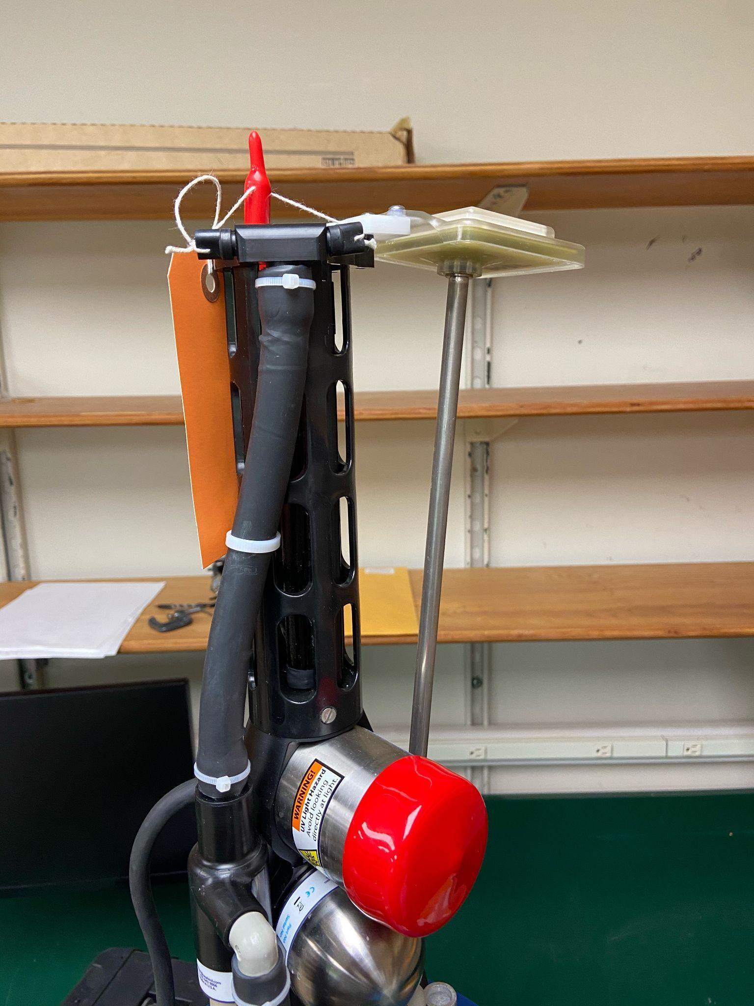

Photo 1B) Remove red tape around SUNA sensor:
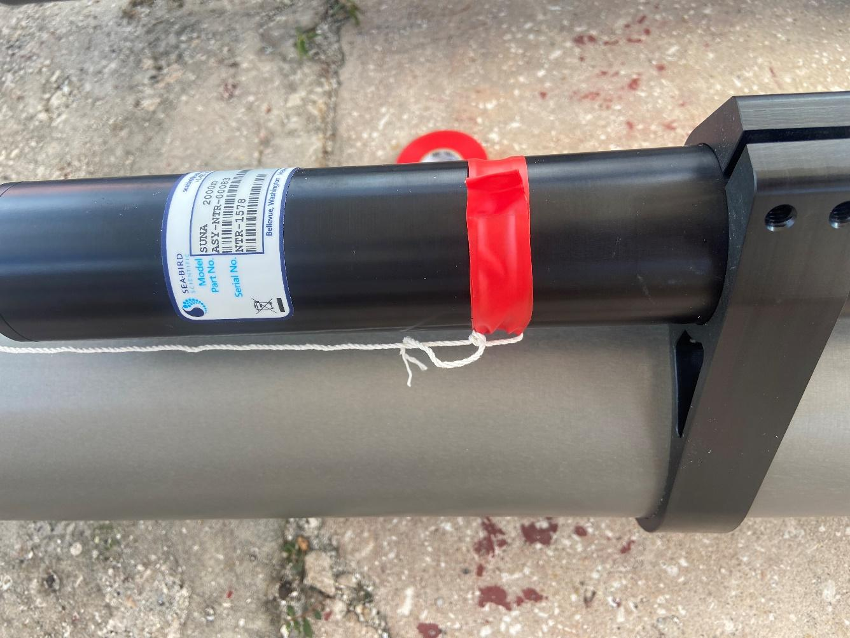

Photo 2) Navis Sensors:
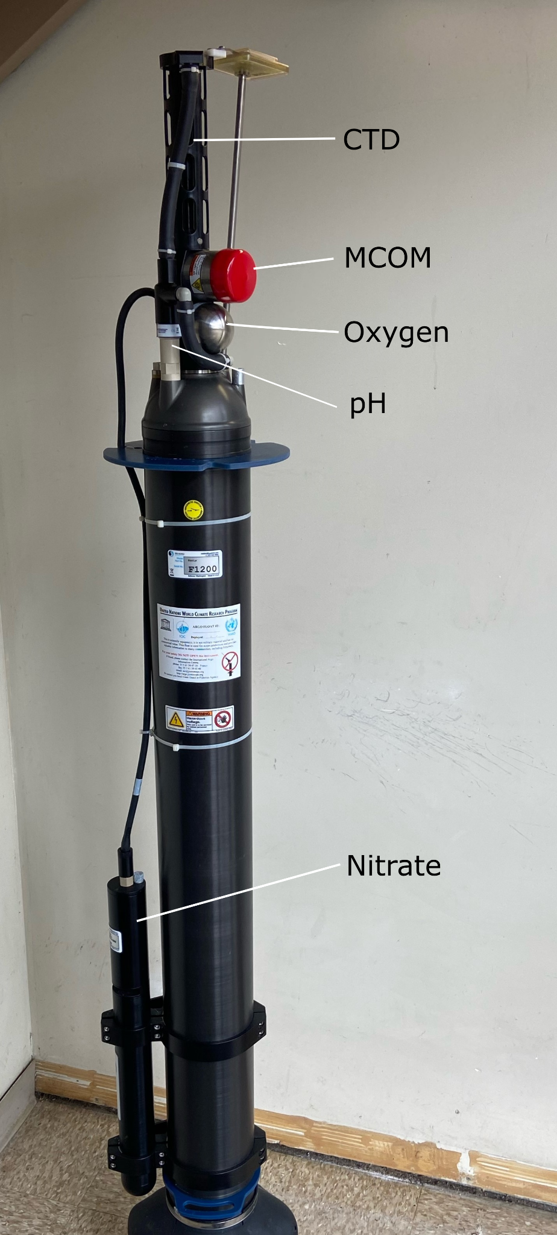
Photo 3) Deployment disk, put deployment line down through hole (red arrow) in blue disk.
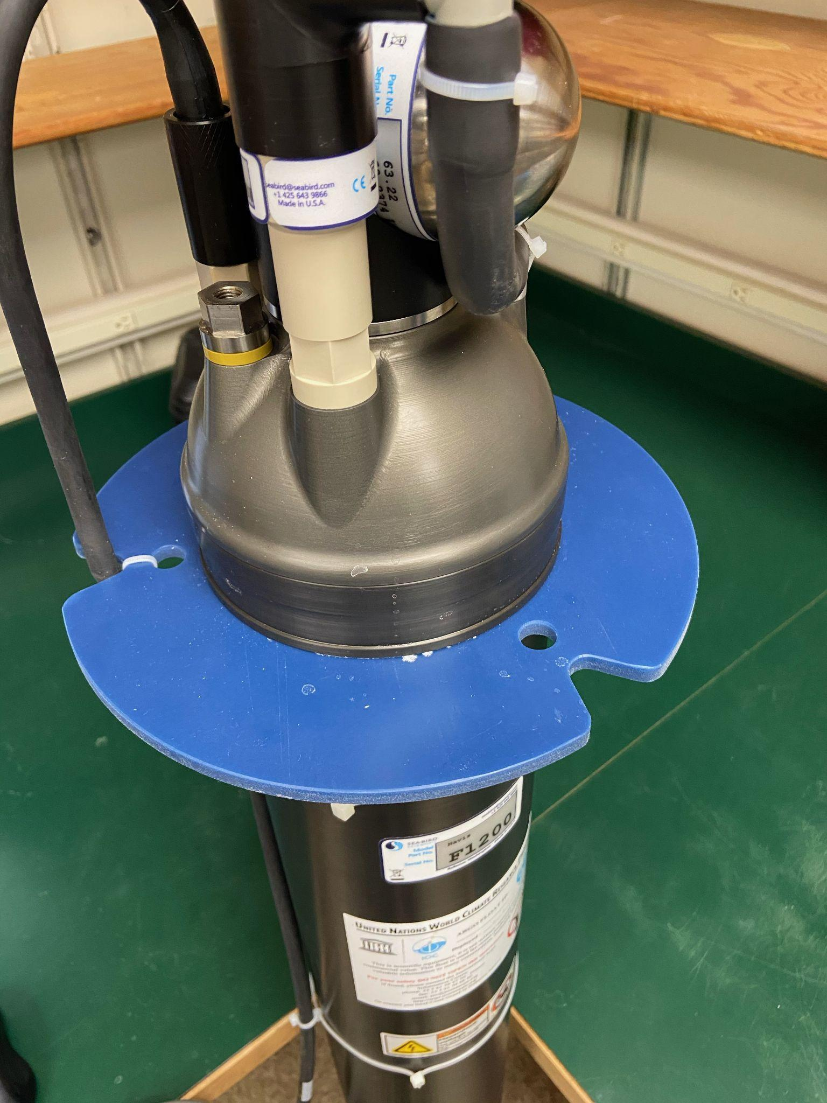

Photo 4) Deployment. Tie one end of line (orange) to a cleat on the fantail. Using two people, lower lines hand over hand to avoid sawing through the deployment disk while lowering. Release bitter end and slide line out of deployment disk.
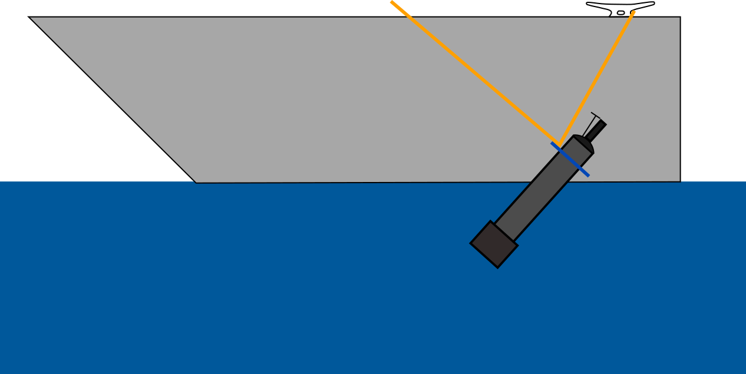

Photo 5) BGC Navis crates. 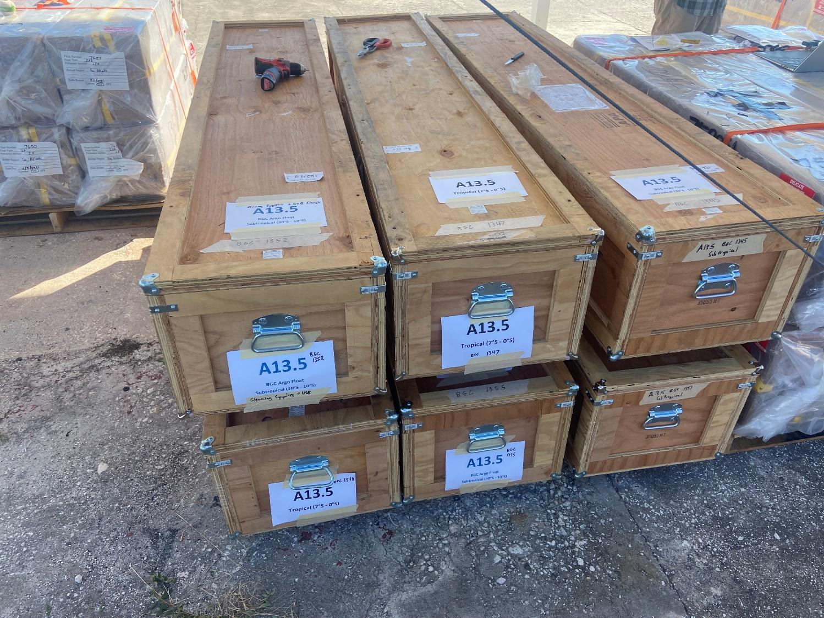

Unboxed Deployment

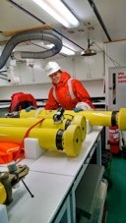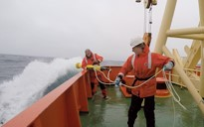

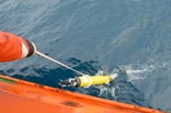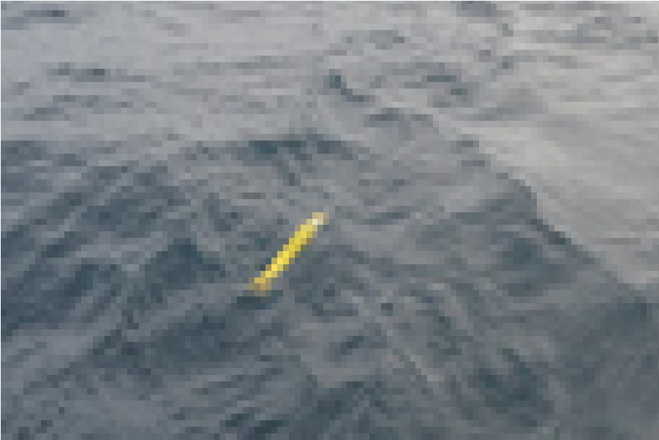

Deployment Video:
http://runt.ocean.washington.edu/rupan/Deployment/UWPalmerLong.m4v
Try not to slide lines through your hands (could end up with rope burn). Try not to get the line wrapped around your head.

